Name: _______________________
Heart Dissection
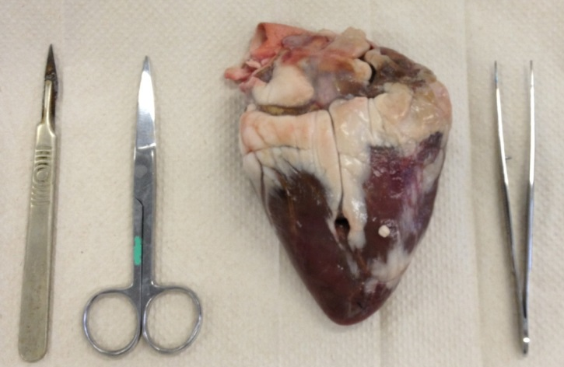
- Put newspaper on the table

- Place heart on tile

- Can you name any parts? Draw a diagram with the names.

- Can you find the beginning of the aorta at the top of the heart? The aorta walls are thick and strong. Why do you think this is?

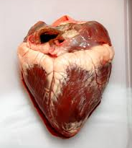

- Make a cut in your heart with the scalpel over the left atria and ventricle (on the right hand side). Do not cut all the way through.

Tick the circles as you find the structures listed:

- Can you see:
- The thick wall of the left ventricle
- The smaller left atria
- The valve between the atria and ventricle
- The strings holding the valve in place
- Make a smaller cut on the other side through the right atria and ventricle (on the left side).

- Can you see:
- The thinner wall of the right ventricle
- The smaller right atria
- The valve between the atria and ventricle
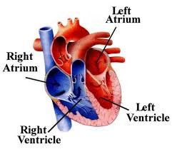
- The strings holding the valve in place

- Why do you think the left ventricle wall is thicker and stronger than the right ventricle wall?


- Place your equipment in the beaker of disinfectant on the front desk

- Wrap your heart in the newspaper and put it in the bin

- Place your tile in the tray at the front and your gloves in the bin.
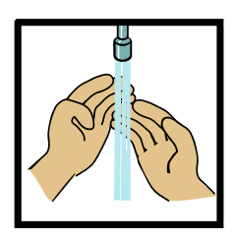
- Wash your hands

Remember: Right is left and left is right
Arteries take blood to the heart
Veins take blood away from the heart

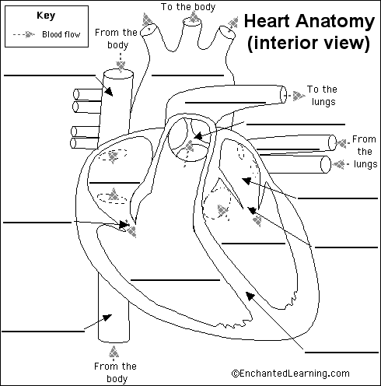

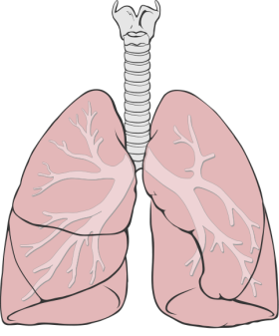
Superior Vena Cava
Aorta
Pulmonary Artery
Valve
Left Atrium
Pulmonary Vein
Right Atrium
Valve
Inferior Vena Cava
Right Ventricle
Septum
Left Ventricle
Valve

